L06 Participation Assignment – Comprehensions & Generators

Background
Explore the use of fuctions.

Procedure
Answer the following questions with cut and paste or screenshots.

- Modify the following code to use both functions (strip_string and uppercase_decorator) as decorators. Show your modified code and output:
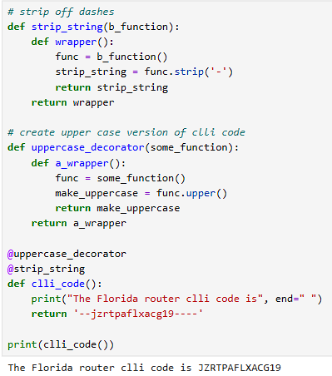

- Create mapped tuples of letter to numeric grades in the lambda function. Run the code and note the output of the lambda function. Wrap the lambda function with a list function and also apply the unpack operator to the ‘a’ parameter in the lambda function. In this context, it is being used as an ‘arbitrary qty of arguments’. Show your revised code and output.
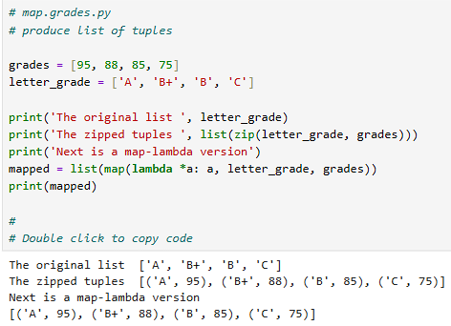

- Modify the code below that checks index 0 of x, and converts the character to upper case to test against clli names that start with either ‘F’ or ‘C’. Lambda should display only 3 clli codes located in Florida or California. Start by applying a filter() function to the existing lambda function. Then, wrap that with a listI() function to unpack into iterables. Next, wrap all of that in a print() function to display the list. Show your revised code and the output:
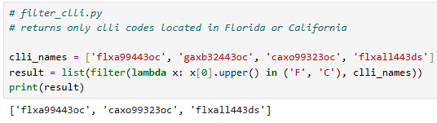

- Complete the following list comprehension to produce the result (in blue) in which x never creates a two-tuple with y if they are equivalent. Replace each underscore with the appropriate Python keyword. Show your revised code and output:
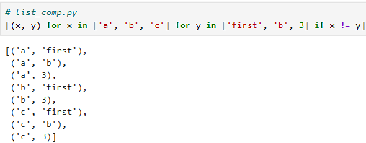

- Code golf is a type of recreational computer programming competition in which participants strive to achieve the shortest possible source code that solves a certain problem. The following code checks a list for negative values. If a negative value is found, the function returns the positive value of the found number. Demonstrate the efficiency of Python by revising the 8 lines of code into two lines of code to produce the same results. Show your code and output.
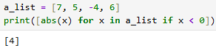

- Correct the code implement a generator comprehension for ‘b’ that produces the same list of 1 million values as does the list comprehension. Generator expressions use () instead of [] braces.
Note the difference in memory using a list vs a generator. Show your code and output:
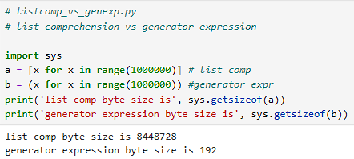

- Submit this word document to Canvas. Use copy and paste or screenshots for the answers. Questions should be included to use as a study guide.

